
PATUAKHALI SCIENCE AND TECHNOLOGY UNIVERSITY
COURSE CODE CIT-112

SUBMITTED TO:

Md. Mahbubur Rahman

Department of Computer Science and Information Technology
Faculty of Computer Science and Engineering

SUBMITTED BY:
Md. Sharafat Karim
ID: 2102024,
Registration No: 10151
Faculty of Computer Science and Engineering

Assignment: 08
Table of Contents
1 Write a function exchange to interchange the values of two variables, say x and y. Illustrate the use of this function, in a calling function. Assume that x and y are defined as global variables. 4
2 Write a function space(x) that can be used to provide a space of x positions between two output numbers. Demonstrate its application. 5
3 Use recursive function calls to evaluate 6
4 Write a function to evaluate the polynomial, using an array variable. 7
5 Write a function that will generate and print the first n Fibonacci numbers. Test the function for n = 5, 10, and 15. 9
6 Write a function that will round a floating-point number to an indicated decimal place. For example the number 17.457 would yield the value 17.46 when it is rounded off to two decimal places. 10
7 Write a function prime that returns 1 if its argument is a prime number and returns zero otherwise. 11
8 Write a function that will scan a character string passed as an argument and convert all lowercase characters into their uppercase equivalents. 12
9 Develop a top_down modular program to implement a calculator. The program should request the user to input two numbers and display one of the following as per the desire of the user: 13
10 Develop a modular interactive program using functions that reads the values of three sides of a triangle and displays either its area or its perimeter as per the request of the user. Given the three sides a, b and c. 15
11 Write a function that can be called to find the largest element of an m by n matrix. 17
12 Write a function that can be called to compute the product of two matrices of size m by n and n by m. The main function provides the values for m and n and two matrices. 19
13 Design and code an interactive modular program that will use functions to a matrix of m by n size, compute column averages and row averages, and then print the entire matrix with averages shown in respective rows and columns. 22
14 modular program of array 25
15 string operation 28
16 Write a program that invokes a function called find( ) to perform the following tasks: 30
17 Design a function locate ( ) that takes two character arrays s1 and s2 and one integer value m as parameters and inserts the string s2 into s1 immediately after the index m . Write a program to test the function using a real-life situation. (Hint: s2 may be a missing word in s1 that represents a line of text). 31
18 Write a function that takes an integer parameter m representing the month number of the year and returns the corresponding name of the month. For instance, if m = 3, the month is March. Test your program. 33
19 In preparing the calendar for a year we need to know whether that particular year is leap year or not. Design a function leap( ) that receives the year as a parameter and returns an appropriate message. What modifications are required if we want to use the function in preparing the actual calendar? 34
20 Write a function that receives a floating point value x and returns it as a value rounded to two nearest decimal places. For example, the value 123.4567 will be rounded to 123.46 (Hint: Seek help of one of the math functions available in math library). 36

1 Write a function exchange to interchange the values of two variables, say x and y. Illustrate the use of this function, in a calling function. Assume that x and y are defined as global variables.

#include<stdio.h>
int a = 10, b = 20;
void swap (void)
{
b = a + b ;
a = b - a ;
b = b - a ;
}
int main()
{
printf("Before swap: a = %d, b = %d\n", a, b);
swap();
printf("After swap: a = %d, b = %d\n", a, b);
return 0;
}
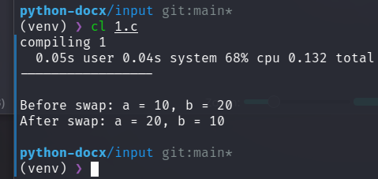

2 Write a function space(x) that can be used to provide a space of x positions between two output numbers. Demonstrate its application.

#include <stdio.h>
void space(int x) {
for (int i = 0; i < x; i++) {
printf(" ");
}
}
int main() {
printf("123");
space(3);
printf("456\n");
return 0;
}
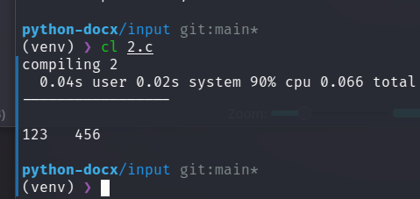

3 Use recursive function calls to evaluate

#include <stdio.h>
#include <math.h>
int factorial(int n)
{
if (n == 1)
return 1;
else
return n * factorial(n - 1);
}
float evaluate(int x, int n, int i)
{
if (n >= 10)
return 0;
else if (i % 2 == 0)
return -pow(x, n) / factorial(n) + evaluate(x, n + 2, i+1);
else
return pow(x, n) / factorial(n) + evaluate(x, n + 2, i+1);
}
int main()
{
int n;
scanf("%d", &n);
printf("%f\n", evaluate(n, 1, 1));
}

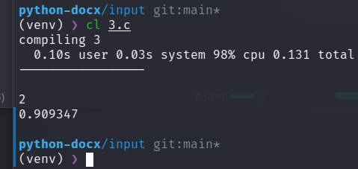

4 Write a function to evaluate the polynomial, using an array variable.

// n order polinoial
// Generated with AI
#include <stdio.h>
#include <math.h>
int factorial(int n)
{
if (n == 1)
return 1;
else
return n * factorial(n - 1);
}
float evaluate(int x, int n, int i)
{
if (n >= 11)
return 0;
else if (i % 2 == 0)
return -pow(x, n) / factorial(n) + evaluate(x, n + 2, i+1);
else
return pow(x, n) / factorial(n) + evaluate(x, n + 2, i+1);
}
int main()
{
int n;
scanf("%d", &n);
printf("%f\n", evaluate(n, 1, 1));
}
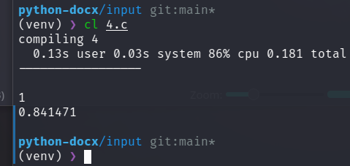

5 Write a function that will generate and print the first n Fibonacci numbers. Test the function for n = 5, 10, and 15.

#include <stdio.h>
void fibonacci(int n)
{
int i, a = 0, b = 1, c;
for (i = 0; i < n; i++)
{
printf("%d ", a);
c = a + b;
a = b;
b = c;
}
}
int main()
{
int n;
printf("Enter number to generate fibonacci series: ");
scanf("%d", &n);
fibonacci(n);
printf("\n");
}

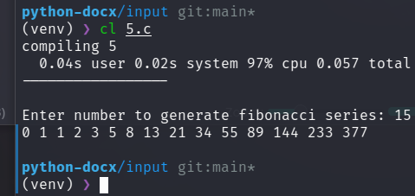

6 Write a function that will round a floating-point number to an indicated decimal place. For example the number 17.457 would yield the value 17.46 when it is rounded off to two decimal places.

#include <stdio.h>
void rounded(float num, int round)
{
printf("%.*f\n", round, num);
}
int main()
{
float num;
int round;
printf("Enter number to round: ");
scanf("%f", &num);
printf("Enter number of decimal places to round to: ");
scanf("%d", &round);
rounded(num, round);
}
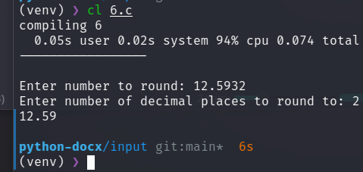

7 Write a function prime that returns 1 if its argument is a prime number and returns zero otherwise.

#include <stdio.h>
int check_prime(int number_to_check_prime)
{
int i;
for (i = 2; i < number_to_check_prime; i++)
{
if (number_to_check_prime % i == 0)
return 0;
}
return 1;
}
int main()
{
int number_to_check_prime;
printf("Enter number to check prime: ");
scanf("%d", &number_to_check_prime);
if (check_prime(number_to_check_prime))
printf("%d is prime\n", number_to_check_prime);
else
printf("%d is not prime\n", number_to_check_prime);
}
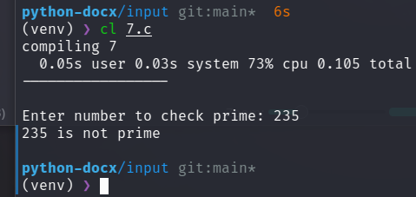

8 Write a function that will scan a character string passed as an argument and convert all lowercase characters into their uppercase equivalents.

#include <stdio.h>
void to_uppercase(char *string)
{
int i;
for (i = 0; string[i] != '\0'; i++)
{
if (string[i] >= 'a' && string[i] <= 'z')
string[i] -= 32;
}
}
int main()
{
char string[100];
printf("Enter string: ");
scanf("%s", string);
to_uppercase(string);
printf("Your uppercase string : \n");
printf("%s\n", string);
return 0;
}

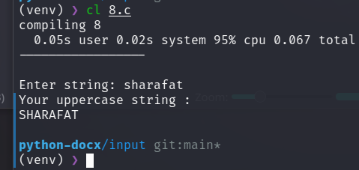

9 Develop a top_down modular program to implement a calculator. The program should request the user to input two numbers and display one of the following as per the desire of the user:

#include <stdio.h>
int sum(int a, int b)
{
return a + b;
}
int difference(int a, int b)
{
return a - b;
}
int product(int a, int b)
{
return a * b;
}
int division(int a, int b)
{
return a / b;
}
int main()
{
int a, b;
char operation;
printf("Enter first number: ");
scanf("%d", &a);
printf("Enter second number: ");
scanf("%d", &b);
printf("Enter one of the followings: ");
printf("\n(a) Sum of the numbers ");
printf("\n(b) Difference of the numbers ");
printf("\n(c) Product of the numbers ");
printf("\n(d) Division of the numbers ");
printf("\n");
scanf(" %c", &operation);
switch (operation)
{
case 'a':
printf("Result -> %d\n", sum(a, b));
break;
case 'b':
printf("Result -> %d\n", difference(a, b));
break;
case 'c':
printf("Result -> %d\n", product(a, b));
break;
case 'd':
printf("Result -> %d\n", division(a, b));
break;
default:
printf("Invalid operation\n");
}
}
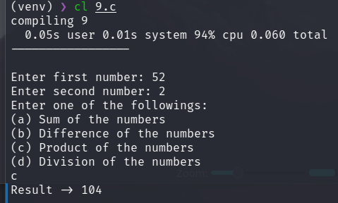

10 Develop a modular interactive program using functions that reads the values of three sides of a triangle and displays either its area or its perimeter as per the request of the user. Given the three sides a, b and c.

#include <stdio.h>
#include <math.h>
float perimeter(float a, float b, float c)
{
return a + b + c;
}
float area(float a, float b, float c)
{
float s = (a + b + c) / 2;
return sqrt((s - a) * (s - b) * (s - c));
}
int main()
{
float a, b, c;
char operation;
printf("Enter first side: ");
scanf("%f", &a);
printf("Enter second side: ");
scanf("%f", &b);
printf("Enter third side: ");
scanf("%f", &c);
printf("Enter one of the followings: ");
printf("\n(a) Perimeter of the triangle ");
printf("\n(b) Area of the triangle ");
printf("\n");
scanf(" %c", &operation);
switch (operation)
{
case 'a':
printf("Result -> %f\n", perimeter(a, b, c));
break;
case 'b':
printf("Result -> %f\n", area(a, b, c));
break;
default:
printf("Invalid operation\n");
}
}
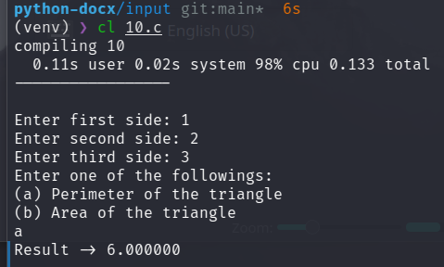

11 Write a function that can be called to find the largest element of an m by n matrix.

#include <stdio.h>
int find_largest(int *matrix, int rows, int cols) {
int i, j, largest = *matrix;
for (i = 0; i < rows; i++) {
for (j = 0; j < cols; j++) {
if (*(matrix + i * cols + j) > largest) {
largest = *(matrix + i * cols + j);
}
}
}
return largest;
}
int main() {
int m, n, i, j;
printf("Enter number of rows and columns: ");
scanf("%d %d", &m, &n);
int matrix[m][n];
printf("Enter matrix elements: \n");
for (i = 0; i < m; i++) {
for (j = 0; j < n; j++) {
scanf("%d", &matrix[i][j]);
}
}
int largest = find_largest(&matrix[0][0], m, n);
printf("Largest element in the matrix is %d\n", largest);
return 0;
}
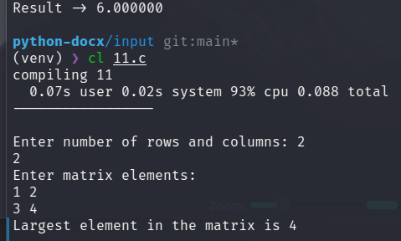

12 Write a function that can be called to compute the product of two matrices of size m by n and n by m. The main function provides the values for m and n and two matrices.

#include <stdio.h>
void multiply_matrices(int *matrix_one, int *matrix_two, int m, int n)
{
int i, j, k;
int result[m][m];
for (i = 0; i < m; i++)
{
for (j = 0; j < m; j++)
{
result[i][j] = 0;
for (k = 0; k < n; k++)
{
result[i][j] += *(matrix_one + i * n + k) * *(matrix_two + k * m + j);
}
}
}
printf("Resultant matrix: \n");
for (i = 0; i < m; i++)
{
printf("[");
for (j = 0; j < m; j++)
{
printf(" %d ", result[i][j]);
}
printf("]\n");
}
}
int main()
{
int m, n;
printf("Enter m and n (mxn) (nxm): ");
scanf("%d %d", &m, &n);
int matrix_one[m][n];
int matrix_two[n][m];
int i, j;
printf("Enter matrix one elements: \n");
for (i = 0; i < m; i++)
{
for (j = 0; j < n; j++)
{
printf("Enter element at (%d, %d): ", i, j);
scanf("%d", &matrix_one[i][j]);
}
}
printf("Enter matrix two elements: \n");
for (i = 0; i < n; i++)
{
for (j = 0; j < m; j++)
{
printf("Enter element at (%d, %d): ", i, j);
scanf("%d", &matrix_two[i][j]);
}
}
multiply_matrices((int *)matrix_one, (int *)matrix_two, m, n);
}

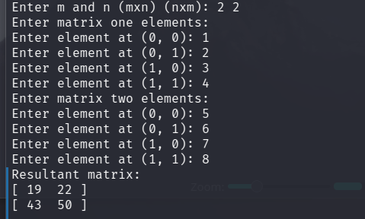

13 Design and code an interactive modular program that will use functions to a matrix of m by n size, compute column averages and row averages, and then print the entire matrix with averages shown in respective rows and columns.

#include <stdio.h>
void input_matrix(int *matrix, int rows, int cols)
{
int i, j;
printf("Enter matrix elements: \n");
for (i = 0; i < rows; i++)
{
for (j = 0; j < cols; j++)
scanf("%d", &matrix[i * cols + j]);
}
}
void print_matrix(int *matrix, int rows, int cols)
{
int i, j;
printf("Matrix: \n");
for (i = 0; i < rows; i++)
{
printf("[");
for (j = 0; j < cols; j++)
printf(" %d ", matrix[i * cols + j]);
printf("]\n");
}
}
void print_row_averages(int *matrix, int rows, int cols)
{
int i, j;
printf("Row averages: \n");
for (i = 0; i < rows; i++)
{
int sum = 0;
for (j = 0; j < cols; j++)
sum += matrix[i * cols + j];
printf("%d\n", sum / cols);
}
}
void print_col_averages(int *matrix, int rows, int cols)
{
int i, j;
printf("Column averages: \n");
for (i = 0; i < cols; i++)
{
int sum = 0;
for (j = 0; j < rows; j++)
sum += matrix[j * cols + i];
printf("%d\n", sum / rows);
}
}
int main()
{
int m, n;
printf("Enter number of rows and columns: ");
scanf("%d %d", &m, &n);
int matrix[m][n];
input_matrix(&matrix[0][0], m, n);
print_matrix(&matrix[0][0], m, n);
print_row_averages(&matrix[0][0], m, n);
print_col_averages(&matrix[0][0], m, n);
return 0;
}
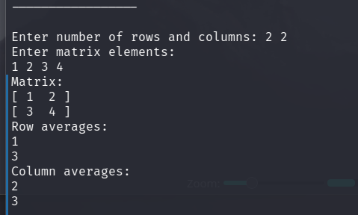

14 modular program of array

// Develop a top-down modular program that will perform the following tasks:
// ```
// (a) Read two integer arrays with unsorted elements.
// (b) Sort them in ascending order
// (c) Merge the sorted arrays
// (d) Print the sorted list
// ```
// Use functions for carrying out each of the above tasks. The main function should have only function calls.
#include <stdio.h>
void input_array(int *array, int size)
{
int i;
printf("Enter array elements: \n");
for (i = 0; i < size; i++)
scanf("%d", &array[i]);
}
void print_array(int *array, int size)
{
int i;
printf("Array: \n");
for (i = 0; i < size; i++)
printf("%d ", array[i]);
printf("\n");
}
void sort_array(int *array, int size)
{
int i, j;
for (i = 0; i < size; i++)
{
int min = array[i], min_index = i;
for (j = i + 1; j < size; j++)
{
if (array[j] < min)
{
min = array[j];
min_index = j;
}
}
int temp = array[i];
array[i] = array[min_index];
array[min_index] = temp;
}
}
void merge_arrays(int *array_one, int *array_two, int *result, int size_one, int size_two)
{
int i, j;
for (i = 0; i < size_one; i++)
result[i] = array_one[i];
for (j = 0; j < size_two; j++)
result[i + j] = array_two[j];
}
void operations(void)
{
int m, n;
printf("Enter size of array one and array two: ");
scanf("%d %d", &m, &n);
int array_one[m], array_two[n];
input_array(array_one, m);
input_array(array_two, n);
sort_array(array_one, m);
sort_array(array_two, n);
int result[m + n];
merge_arrays(array_one, array_two, result, m, n);
sort_array(result, m+n);
print_array(result, m + n);
}
int main()
{
operations();
return 0;
}
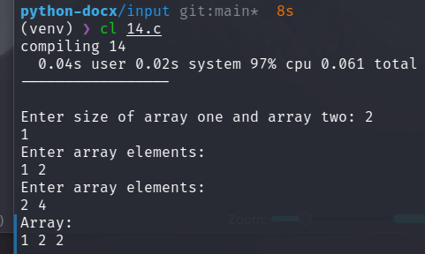

15 string operation

#include <stdio.h>
void copy_string(char *one, char *two)
{
int i;
for (i=0; one[i] != '\0'; i++)
two[i] = one[i];
two[i] = '\0';
return;
}
void compare_string(char *one, char *two)
{
int i;
for (i=0; one[i] != '\0'; i++)
if (one[i] != two[i])
break;
if (one[i] == '\0' && two[i] == '\0')
printf("Strings are equal\n");
else
printf("Strings are not equal\n");
return;
}
void concat_string(char *one, char *two)
{
int i, j;
for (i=0; one[i] != '\0'; i++);
for (j=0; two[j] != '\0'; j++)
one[i+j] = two[j];
one[i+j] = '\0';
return;
}
int main()
{
char string_one[100], string_two[200];
printf("Enter your string: ");
fgets(string_one, 100, stdin);
copy_string(string_one, string_two);
printf("Your second string is: %s", string_two);
compare_string(string_one, string_two);
concat_string(string_one, string_two);
printf("Your concatenated string is: %s", string_one);
return 0;
}

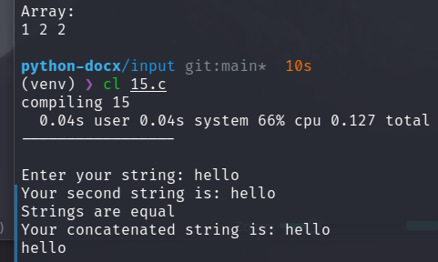

16 Write a program that invokes a function called find( ) to perform the following tasks:

#include <stdio.h>
int char_search_inside_string(char *string, char c)
{
int i;
for (i=0; string[i] != '\0'; i++)
if (string[i] == c)
return i;
return -1;
}
int main()
{
char string[100], c;
printf("Enter your string: ");
fgets(string, 100, stdin);
printf("Enter your character: ");
scanf("%c", &c);
int index = char_search_inside_string(string, c);
if (index == -1)
printf("Character not found\n");
else
printf("Character found at index %d\n", index);
return 0;
}

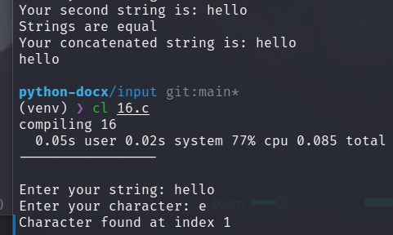

17 Design a function locate ( ) that takes two character arrays s1 and s2 and one integer value m as parameters and inserts the string s2 into s1 immediately after the index m . Write a program to test the function using a real-life situation. (Hint: s2 may be a missing word in s1 that represents a line of text).

#include <stdio.h>
char* locate(char *s1, char *s2, int m)
{
int i, j;
static char temp[100];
for (i=0; i< m; i++)
temp[i] = s1[i];
for (j=0; s2[j] != '\0'; j++)
temp[i+j] = s2[j];
for (; s1[i] != '\0'; i++)
temp[i+j] = s1[i];
return temp;
}
int main()
{
char s1[100], s2[100];
int m;
printf("Enter your string: ");
scanf("%[^\n]s", s1);
printf("Enter your string: ");
scanf(" %[^\n]s", s2);
printf("Enter your index: ");
scanf("%d", &m);
char *updated_string;
updated_string = locate(s1, s2, m);
printf("Your string is: %s", updated_string);
return 0;
}
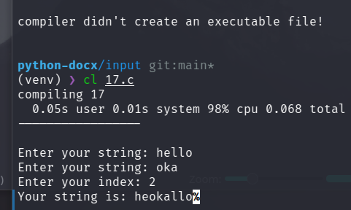

18 Write a function that takes an integer parameter m representing the month number of the year and returns the corresponding name of the month. For instance, if m = 3, the month is March. Test your program.

#include <stdio.h>
char *month_name(int m)
{
char *months[] = {
"January", "February", "March", "April", "May", "June", "July", "August",
"September", "October", "November", "December"};
return months[m - 1];
}
int main()
{
int m;
printf("Enter month number: ");
scanf("%d", &m);
printf("Month name: %s\n", month_name(m));
return 0;
}
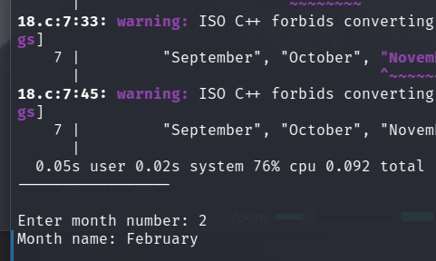

19 In preparing the calendar for a year we need to know whether that particular year is leap year or not. Design a function leap( ) that receives the year as a parameter and returns an appropriate message. What modifications are required if we want to use the function in preparing the actual calendar?

#include <stdio.h>
int leap(int year)
{
if (year % 400 == 0)
return 1;
else if (year % 100 == 0)
return 0;
else if (year % 4 == 0)
return 1;
else
return 0;
}
int main()
{
int year;
printf("Enter year: ");
scanf("%d", &year);
if (leap(year))
printf("%d is a leap year.\n", year);
else
printf("%d is not a leap year.\n", year);
return 0;
}
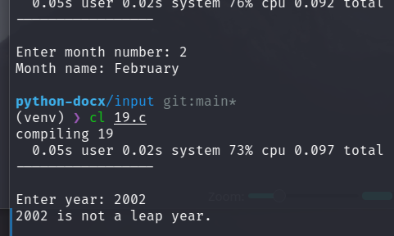

20 Write a function that receives a floating point value x and returns it as a value rounded to two nearest decimal places. For example, the value 123.4567 will be rounded to 123.46 (Hint: Seek help of one of the math functions available in math library).

#include <stdio.h>
#include <math.h>
double round2(double x)
{
return round(x * 100) / 100;
}
int main()
{
double x;
printf("Enter a floating point value: ");
scanf("%lf", &x);
printf("Rounded value: %.2lf\n", round2(x));
return 0;
}
